**Lecture notes for Chapter no 4 and 5**

**Checking of Linear combination**:

Check whether w is a linear combination of v1,v2,v3

For square systems

* If Det(Coefficient Matrix) is not equal to zero then w is a linear combination of v1,v2,v3.
* If Det(Coefficient Matrix) is equal to zero no conclusion by determinant(check whether system is consistent or inconsistent).

For Rectangular system:

* **If system is consistent then w will be a linear combination of** v1,v2,v3.**.**
* **If system is in consistent the w will not be a linear combination of** v1,v2,v3.

**Checking of spanning:**

* **If system is unconditionally consistent then it will Span a space.**
* **If system is inconsistent or conditionally consistent then it will not Span a space.**

**Solved Example no 1:**

**Whether the vectors (3,1,4), (2,-3,5), (5,-2,9) and (1,4,-1) will span R3.**

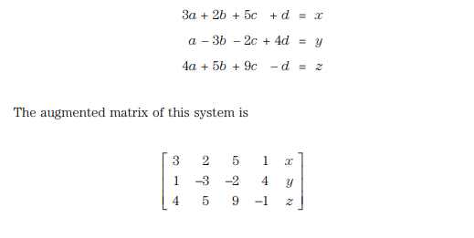

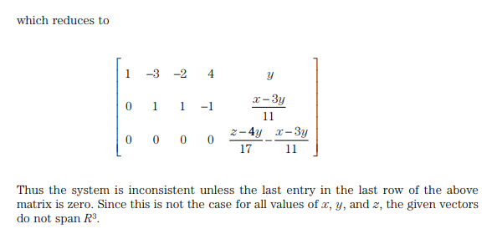

**Example no 2 (4.2 Qno 13)**

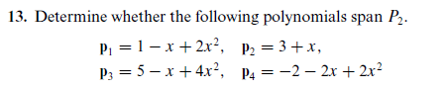

**Solution**

**(Here P2 is referring to any polynomial of second degree)**

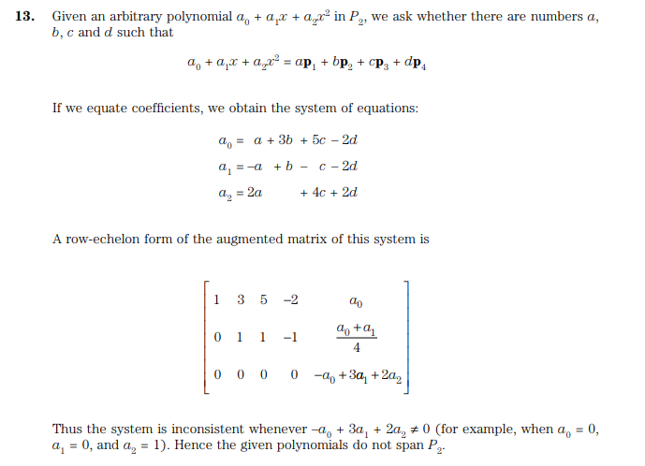

**Checking of Linear Dependence:**

For Linear dependence we check whether the system

Has only one solution or infinite many solution

* If it has only one solution then v1,v2,v3,…,vn are linearly independent.(Det of coefficient matrix is not equal to 0)
* If it has many solution then v1,v2,v3,…, vn are linearly dependent. (Det of coefficient matrix is equal to 0)
* **If system has trivial solution then** v1,v2,v3,…,vn are linearly independent.
* **If system has non trivial solution then** v1,v2,v3,…,vn are linearly independent.



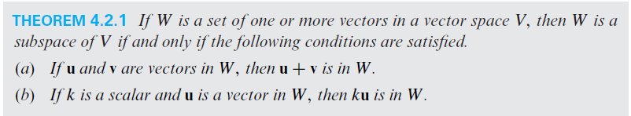

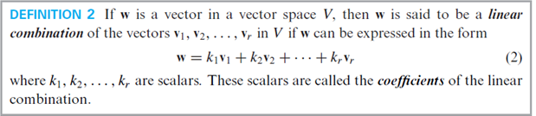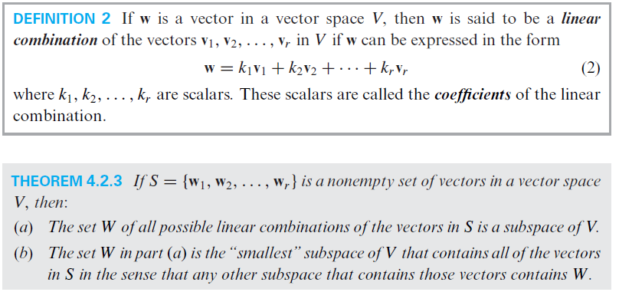

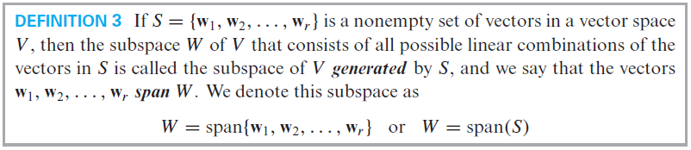



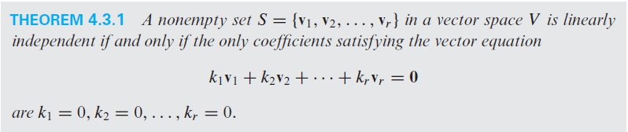

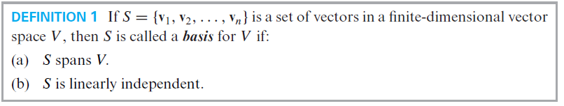

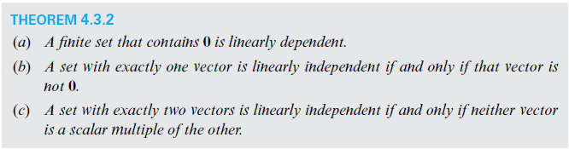



Example:

Let S = {v1, v2, v3 ,v4} be a set in R3. r=4, n=3 here as r > n so S will be linearly independent.

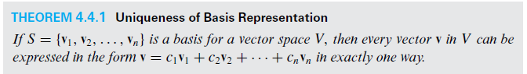

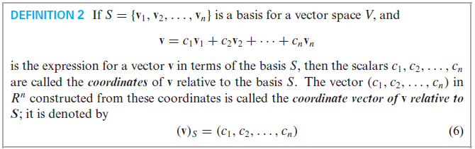

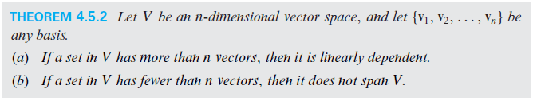

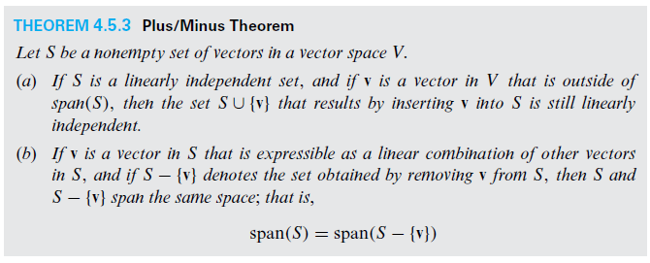

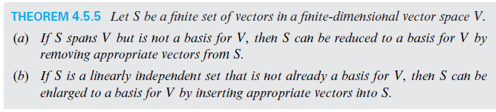

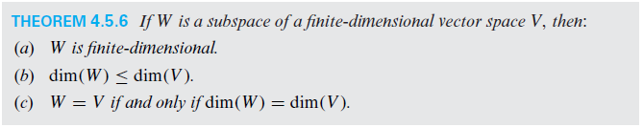



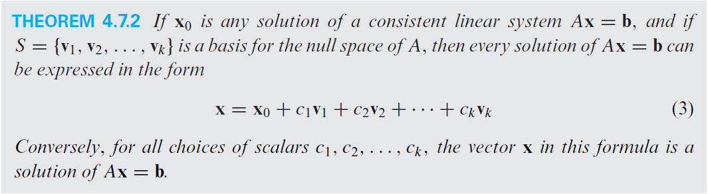



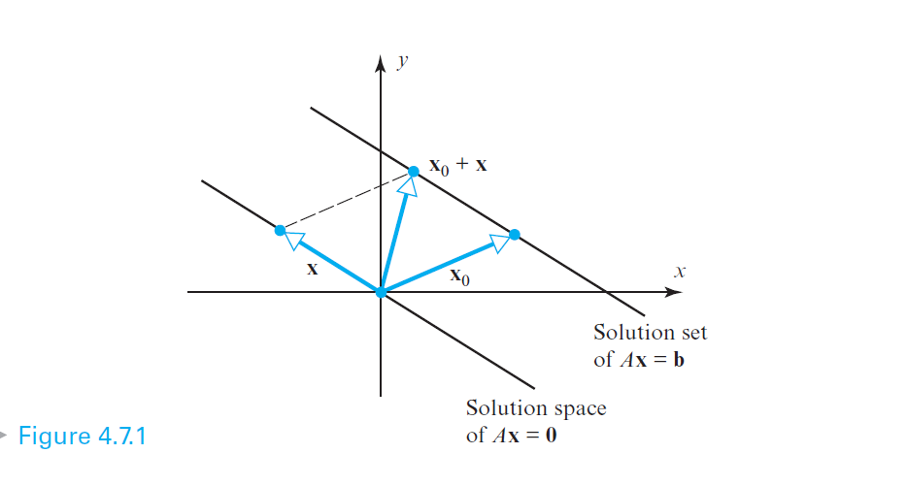





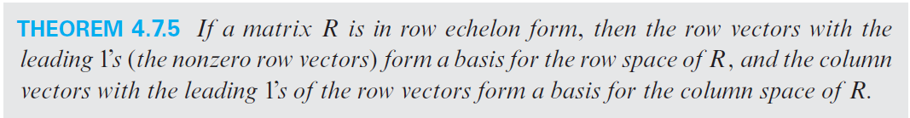

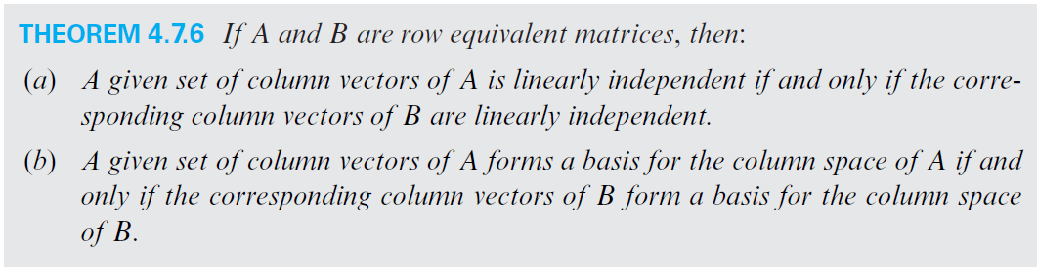





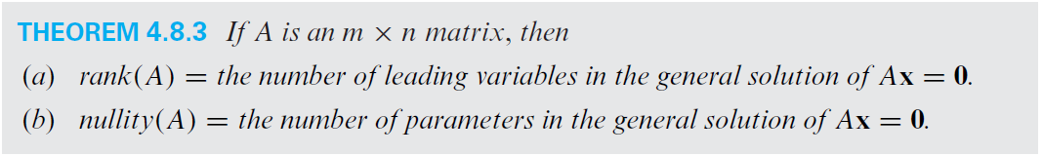







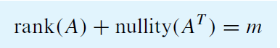

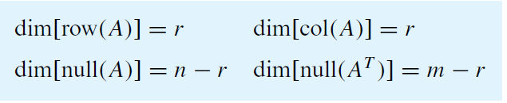

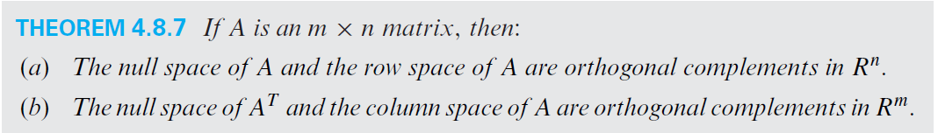

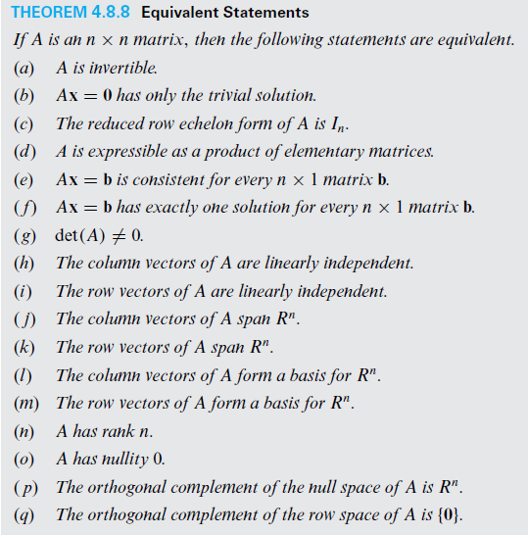

**Chapter no 5**

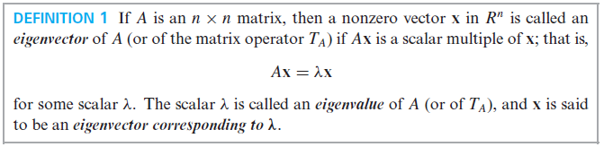



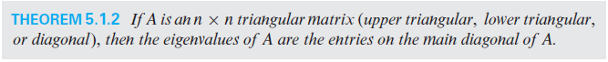

a) b) c)

Eigen values of matrix a) 2, 4 and -5

Eigen values of matrix b) 2, 4 and -5

Eigen values of matrix c) 2, 9 and -5

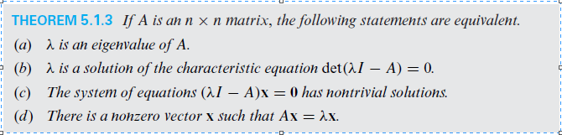



Example:

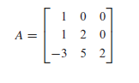

Eigen values of A are 1 and 2 so A is invertible

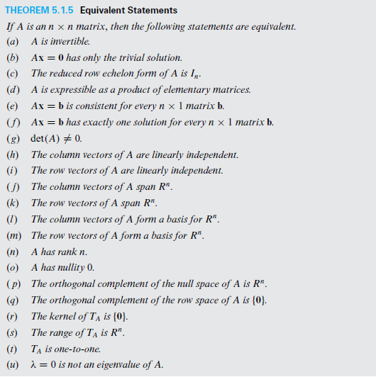

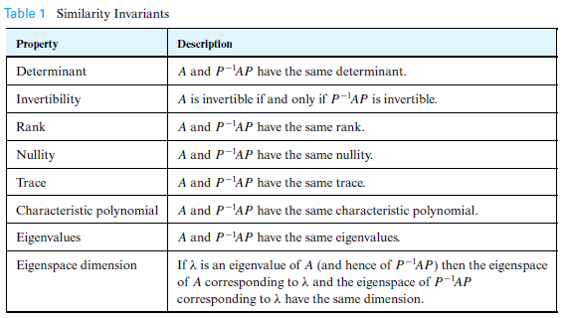



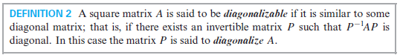

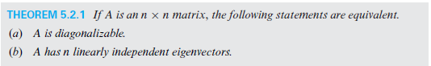

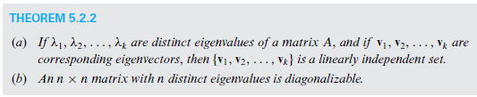

Example:

1- If A is a 3x3 matrix and A has three distinct Eigen values then A is diagonalizable.

2- If A is a 3x3 matrix and A has two distinct Eigen values then we will check the dimension of eigen space corresponding to each eigen value. If sum of all eigen vectors corresponding to all distinct eigen values is equal to 3 then A is diagonalizable.

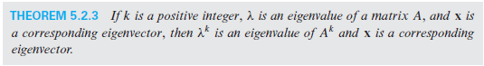

Example:



Eigen values of A are 1 and 2

While basis of eigen space or eigen vectors

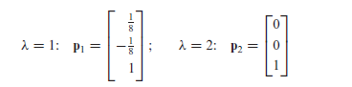

For A7

Eigen Values are 17 and 27

While basis of eigen space or Eigen Vectors will be

